

Questionnaire for

Inquiry/ Order of Rope Pulleys
Tel. +49 3334 38 66 0
Fax: +49 3334 38 66 20
mail@bamos.de

Estimated client,

Your details on the parameters contained in the table allow us to submit a detailed offer according to your special requirements.
As far as possible, please give us the following data together with your inquiry.

Client/ Company:
Address:
Contact Person:
Phone: Fax: E-Mail:

Quantity (units): Required period:

Nominal ø d₁ (mm) : Contact angle (°):
Rope ø d_{s} (mm) : Axle load F_{L} stat/dyn (kN):
Rope load F_{s} stat/dyn (kN) : or Axial load stat/dyn (kN):
Sloped angle (°): Required lifetime of the bearing (h):
Revolution n (1/min) :
Classification of the rope pulley : According to:
Environmental conditions :
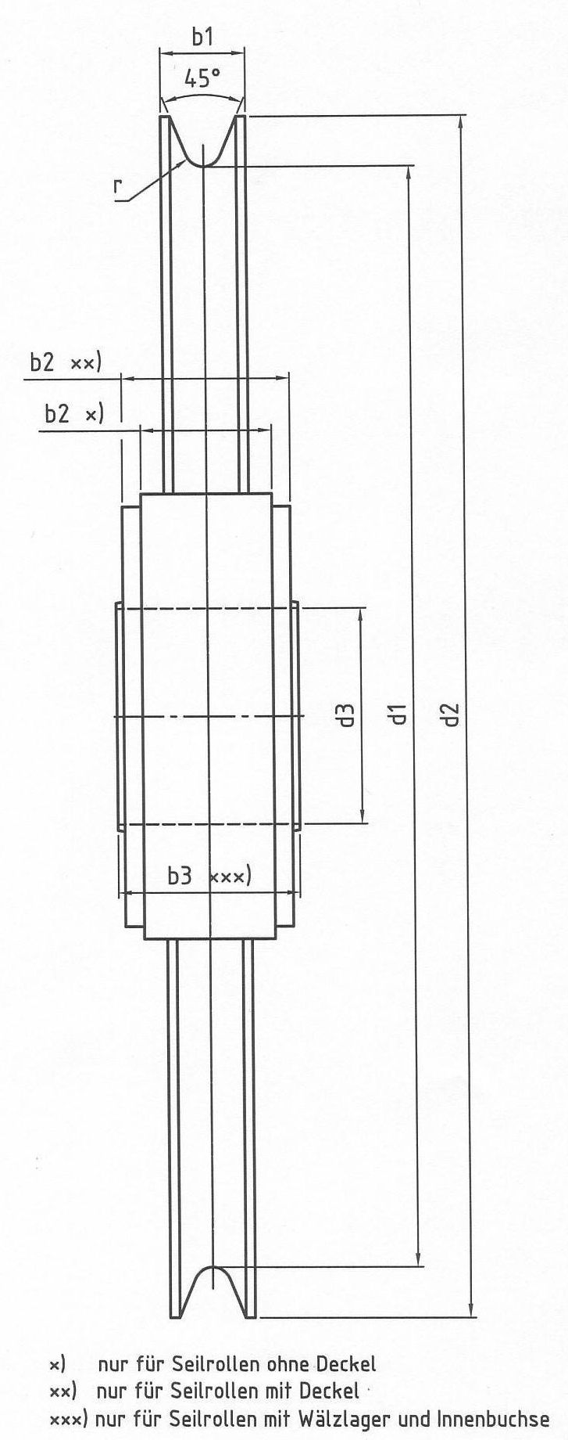
Outer ø d₂ (mm) :
Axle ø d₃ (mm) :
Bearing (type/ dimensions):
Width over pulley rim b₁ ( mm) :
Hub breadth b₂ (mm) :
Width over lid b₂ (mm):
Width of Inner bushing b₃ (mm):
Other requirements:

ø = diameter

